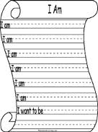
I am…

You’re an interesting person. It’s true, even if you don’t believe it at this very moment. If you don’t find yourself interesting we can both agree that you’re at least a person. And if you’re going to say that you’re NOT a person, well then you’re definitely interesting.

TASK 1:
Write a poem about yourself that is AT LEAST 16 lines. Yes you, yes 16 lines! Formatting is up to you but it CANNOT be an acrostic poem.

TASK 2:
Your second (AT LEAST 16 line) poem will be about someone or something else. It can be about someone famous, someone fictional or SOMETHING!

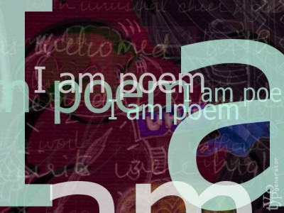
TASK 3:
Decide how to “present” ONE of your poems.

Option 1: Read the poem out loud in class.
When speaking in front of the class you will be
assessed on YOUR personal ability to speak,
so do your best.

Option 2: Create a physical reprsentation of your poem.
Take (or create) an object to represent your poem.
Be creative and present your poem on the object to maximize its effect.

You will be assessed USING THE RUBRIC ON THE BACK of this page

I AM POEM Rubric

Excellent  25 | The word choice and style is appropriate and well thought-out. The student skillfully uses literary devices throughout. Delivery of the poem is done confidently and passionately. OR Finished product is expertly connected to the poem and shows polish.
Proficient  20 | The word choice and style is appropriate. The student uses literary devices throughout. Delivery of the poem is done confidently. OR Finished product is connected to the poem and is neatly done.
Satisfactory  15 | The word choice and style is appropriate. The student uses some literary devices. Delivery of the poem is done with some confidence. OR Finished product is superficially connected and neatly done.
Limited  10 | The word choice or style is not appropriate. The student barely uses literary devices. Delivery of the lacks confidence. OR Finished product is barely connected to the poem and lacks neatness.
* Can receive lower than 10 if assignment requirements (number of lines, topic, presentation etc.) are not met.

Your 2nd poem (not performed/presented) will follow the same rubric but be on a 15 point scale (15, 12, 8, 4) due to no performance requirement.

